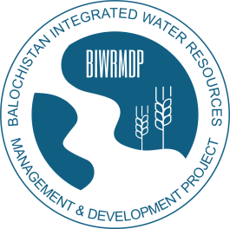 | No. PD/BIWRMDP/MUSHKAF/SCH/ /VOL - I  OFFICE OF THE PROJECT DIRECTOR  BALOCHISTAN INTEGRATED WATER RESOURCES  MANAGEMENT & DEVELOPMENT PROJECT  215-B, Jinnah Town, Samungli Road, Quetta.  Phone/ Fax: 92-81-2870705 Email: biwrmdp@gmail.com www.ssip@yahoo.com
 | Dated: Quetta the 22nd March 2019

ADDENDUM No. 02

To

All the Prospective Bidders/Constructing Firms
Participating in Bidding for award of Civil Works Contracts under BIWRMDP

Subject:- COSTRUCTION OF MUSHKAF FLOOD IRRIGATION SCHEME
Addendum No. 02 to Bidding Documents.

In exercise of powers conferred by Instructions to Bidders Clause 8 Section – 1, Volume -1 of the Bidding Documents, the Project Director is pleased to issue this Addendum -2 to Bidding Documents of Mushkaf Flood Irrigation Scheme, thereby correcting the percentage of Stamp Duty as 0.25 percent instead of 0.35 that was errorneously typed in the Data Sheet against Clause 44 of Section-I “Instructions to Bidders”.

The addendum, however, will not affect the cutoff date for submission of the bids which will remain unchanged, i.e 4th April 2019

Please acknowledge receipt of this Addendum.

Project Director
BIWRMD Project

