REQUEST FOR QUOTATION

BALOCHISTAN INTEGRATED WATER RESOURCES MANAGEMENT AND DEVELOPMENT PROJECT (BIWRMDP)

PROCUREMENT OF
Baseline Sampling (Ambient Air/Noise/Water) for Nur-Hingri-Gunacha Irrigation Scheme Under
BIWRMD PROJECT

(January- 2018)

18-B, Jinnah Town Quetta - Phone # 081-2870705 Fax # 081-2870704

No.BIWRMDP/RFQ/GOODS-2/ 351 / VOL-V
Date:25-01-2018
Page No: 07

Section 1
Subject: Request for Quotations for Baseline Sampling (Ambient Air/Noise/Water) for Nur-Hingri-Gunacha Irrigation Irrigation Scheme.

- The Government of Balochistan is negotiating a loan from the World Bank, and intends to apply part of the proceeds of this credit to eligible payments under the contract for which this Request for Quotations is issued. This procurement process will be conducted in accordance with the Shopping method of procurement contained in the World Bank Guidelines: Procurement of Goods, Works and Non-Consulting Services under IBRD Loans and IDA Credits and Grants by World Bank Borrowers, dated: January 2011, revised July 2014 and the procedures described herein.

- The Implementing Agency Balochistan Integrated Water Resources Management and Development Project invite Quotations for Baseline Sampling (Ambient Air/Noise/Water) for Nur-Hingri-GunachaIrrigation Scheme described in Section II, For the purposes of any resulting Contract the Implementing Agency or their named representative shall be the Purchaser.

- Your quotation should be accompanied by adequate technical documentation, experience certificates, work orders and other printed materials.

- Your quotation must reach at the address mentioned above by 12:00 Hours of 6th Feb, 2018.

Prices: The prices should be quoted in Pak Rupees and should be inclusive of all admissible taxes.
Evaluation And Award Of Purchase Order/Contract: Offers determined to be substantially technically responsive will be evaluated by comparison of their prices, The Contract will be awarded to the firm offering the lowest evaluated price and that meets the eligibility criteria.
Validity of the Offer:Your quotation(s) should be valid for a period of 40 days from the date for receipt of quotation(s) indicated in Paragraph 6 above.

Section 11

Terms of Reference

Background.
Water is scarce in Balochistan as a whole. The province often faces severe drought conditions. Water availability is drastically reduced during extended droughts which leads to high marginality in income and livelihood means. Water storage facilities are inadequate for both surface and groundwater and the poor conditions of hydraulic structures require urgent rehabilitation and regular maintenance. The lack of adequate water storage capacities and flood retention areas as well as flood protection embankments have led to high damages. Urgent efforts and investments are required for rehabilitation of hydraulic infrastructure and implementation of water conservation as well as flood protection measures.
The Government of the Islamic Republic of Pakistan, represented by the Government of Balochistan (GoB), has received a loan from The World Bank/IDA for the implementation of the Balochistan Integrated Water Resources Management & Development Project (BIWRMDP).
The Project Development Objective (PDO) is to strengthen provincial government capacity for water resources monitoring and management, and to improve community/based water management for targeted irrigation schemes in Balochistan. The project has 3 main components and 9 sub-components. Among others, the Sub-Component B-1 is designed to invest in rehabilitation of six irrigation schemes located in Nari and Porali River Basins of Balochistan while following an Integrated Water Resources Management (IWRM) approach; to ensure sustainable livelihood and improve resilience of the beneficiary communities. The project is implemented by a Project Management Unit (PMU) in Quetta and two Project Implementation Units (PIUs) in Sibi and Uthal, respectively. The Implementation of the project has been facilitated by a number of individual consultants, including an environmental safeguard consultant, and two long term consultants which shall play a vital role in implementation and monitoring of the project.

Description of Sub-Project and Location

The Gundacha area lies along the middle reach of the Porali River. The river flowing in this reach covers a CCA of around 6000 acres. The main issue at Gundacha is the uncontrolled flow entering the Command area. The Gundacha –NurgHingri Irrigation Scheme (GNHIS) package proposes a reliable diversion system at the Gundacha stretch of Porali River.

The NurgHingri area lies at about 5 km downstream of the Gundacha village. The existing Nurg and Hingri Weirs command the area through flood flows and cover about 8,000 and 12,000 acres respectively. The major issue in this area is the open crest high volume discharge in the downstream earthen channels. This package proposes an improvement of existing Nurg-Hingri diversion Structures and conveyance channels.

The GNHIS Package will result in overall socio-economic up-gradation of the locals and will considerably benefit the farming communities as well.

Objective and Scope of Work

The overall objective of this baseline study is to provide real time data of Gundacha Irrigation Scheme. This proposed study is to collect the baseline ambient air quality, noise, water, soil sampling data from the sub-project area. The data of air quality, noise and meteorological parameters be collected with the interval of 01 hour for 24 hours at each site. The firm shall also prepare and produce a detail baseline report on baseline data.
The locations provided in this TORs may change in accordance to the need of the sub-project area.

  - Ambient Air & Noise Monitoring

  - Site/Locations

The site locations/points of ambient air/noise monitoring are given in below image. These may change. If required.

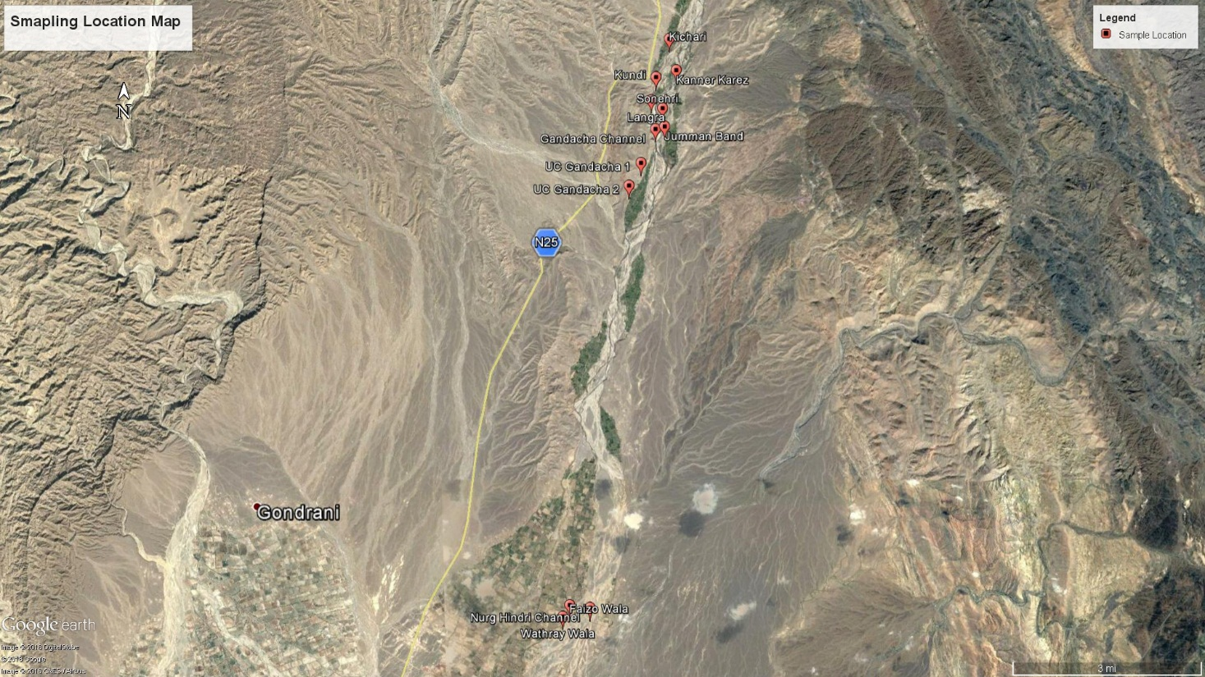

  - Parameters to be monitored

- Nitrogen oxides (NOx)
- Sulpur Dioxide (SO2)
- Corbon Monoxide (CO)
- Noise Level
- Lead
- Particulate Matter (PM10)
- Total Suspended Particulate (TSP)
- Meteorological Parameters (Wind speed, wind direction, ambient temperature, relative and humidity).

- Water Quality Testing
In total 10 water samples to be collected from giving locations.
- One Water Sample from Ground Water/Drinking Water (Upstream side & Downstream side)
- One Water Sample from Surface/Irrigation Water (Upstream side &Downstream side).

- Locations:

- Gundacha Channel
- Jammot Channel
- Nurg-Hingri (Only from Weir Location, Surface/Irrigation water)

A).Physical Test
Color, Odor, Taste, Turbidity, Conductivity, pH, TDS, TSS
B). Chemical Test
Alkalinity,Bio-carbonate, Chlorides, Hardness (CaCo3), Magnesium, Potassium, Sulpate, Nitrate, Fluoride, Iron, Arsenic, , Calcium, Copper, Zinc, Mercury, Copper, Ammonia, Nitrite ,Selenium
C). Microbiological Test
- Total Coliforms
- Fecal Coliforms
- E.Coli

- Soil Analysis
The firm will require collecting of one sample from the head and one sample from the tail end of each channel of sub-project area. The sampling locations are provided below.
- Gundacha Channel (U/S an D/S)
- Jammot Channel (U/S an D/S)
- Nurg-Hingri (Only from Weir Location)

The following test to be conducted:
- Analysis of pollutants/chemicals
- The laboratory measurements of organo-chlorine pesticides for sediments quality.

Qualification

The approved organization from EPA, ISO 2001 and World Bank is eligible for this baseline study.

Payment Terms and Conditions
- XX% payment of award of work.
- XX % payment at submission of first draft final report
- XX% payment after approval of the World Bank.

Time
The stipulated time for completion of this assignment is 10 Days (Including Submission of Report).

